**51987567 – CS1257 Mini Project Manual**

**Description and rules of the game**

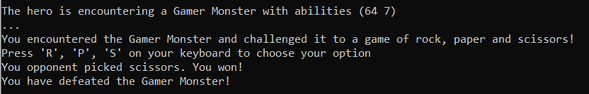In the game, the player is represented as a hero, which is shown as “H” on the maze. The aim of the game is to encounter and fight every Monster character, which are shown as “M” on the maze, at least once with your health being greater than 0 in order to win. If hero’s heath is equal or below zero the player loses the game. At the start of the game the hero is given 100 health and 1000 coins, which can change trough out the game based on what rout the player choses and trough encounters with monsters/goblins. Monsters are hostile entities which damage or steal coins, or do both depending on the type. There are 3 different types of monsters: Theft, Fighter and Gamer monsters. On the other hand, goblins, which are shown as “G” on the maze, are friendly entities, which help the player by healing the hero or awarding coins, or doing both depending on the type. There are 3 different types of goblins: Wealth, Health and Gamer goblins. Theft and Fighter monsters, also Wealth and Health goblins work to a probability chance i.e. there is a random percentage the monster could damage or steal coins from the player, or the goblin rewarding with coins or healing the player. The Gamer monster and goblin are based on the “Rock, Paper, Scissors” game. If the player loses the game against the Gamer monster, the hero loses a certain amount of damage and loses a certain amount of coins, and if they win, they pass the monster without any casualties. On the other hand, if the player wins the game against the Gamer goblin, the player will be rewarded with health and coins, otherwise they do not again anything. The process of the “Rock, Paper, Scissors” is showed below:

As shown above, the Gamer monster has an ability of (64 7), which means if the player loses the game of “Rock, Paper, Scissors” the hero will lose 64 coins and 7 health. If the hero encounters an entity that is based on percentage, the process that happens is showed below: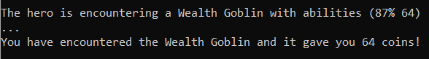

As shown the player is warned with information that tells what kind of entity the hero is encountering. At this situation the player encounters Wealth goblin with abilities (87% 64), which means that the hero has 87% chance to receive 64 coins.

**How to play**

Before the actual game starts, the player is greeted by two messages:



The player has to select a difficulty for the game or also has the option of loading previously saved game if there was one saved in the first place. To select a difficulty, the player has to press 1, 2, 3 or 4 on their keyboard.

As the difficulty increases two things happen: The monster’s percentage and damage/steal amount increase, and the goblin’s percentage decreases, but the healing/coins amount increases.

After selecting the difficulty, the player is greeted and is ready to play the game. The screen will look similar to this:

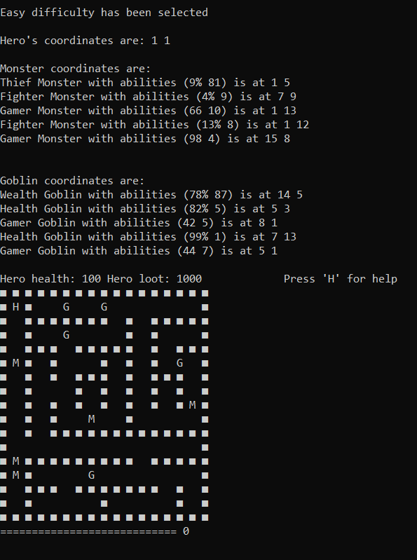

The player at first will be shown all coordinates of all entities and their abilities, this information will not be printed every time the player moves. To print the coordinates and abilities of all entities, the player has to press “M”.

The controls of the games can be accessed by pressing “H”: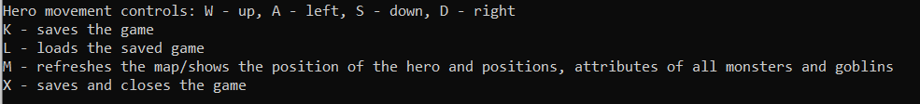

The map is a randomly generated 17x17 maze with one hero, 5 monsters and 5 goblins. Every randomly generated maze includes at least one of the three types of monsters or goblins that were named at the start. The hero can only move in the empty space with w, a, s, d keyboard keys. Movement would look like:

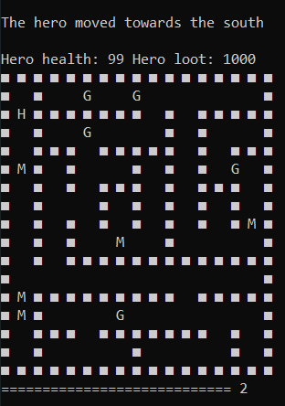

Hero position after pressing “S”

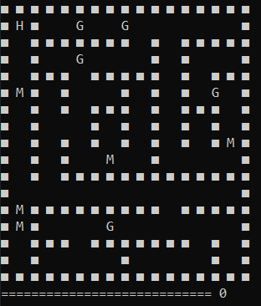

Hero position before pressing “S”

If the player tries to walk into the wall, which is “■”, it will be waned with a message:



If the hero’s health is < 0, then the player loses the game. The player will be warned with a message: 

Otherwise, if the player has encountered all the 5 monsters and has more than 0 health, then the player will be greeted with a victory screen and leaderboards, which show top 10 players of every difficulty that have been recorded:

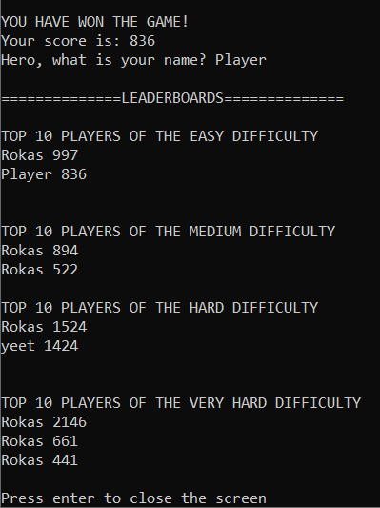

At this situation the player has one the game with a score of 836 at the level difficulty of “Easy”, the players name has been put into EASY leaderboard hence also ending the game in success.

**How to open the game**

To open the game, go to the “Source code” folder and open the playgame.py file.

P.S The game was programmed in Windows OS. There might be bugs in other OS systems, so for best performance please play this game on Windows OS.

**UML Diagram**

